EXERCISE NO: 5
DATE:24.10.2020
AIM:
To write a python program to print the missing characters to make the string pangram.
PROGRAM:
def pangram(string):
alphabets = "abcdefghijklmnopqrstuvwxyz"
for letter in alphabets:
if letter not in string.lower():
print(letter,end = "")

string = input()
pangram(string)
LINK:
http://103.53.53.18/mod/vpl/forms/submissionview.php?id=235&userid=1757

OUTPUT:

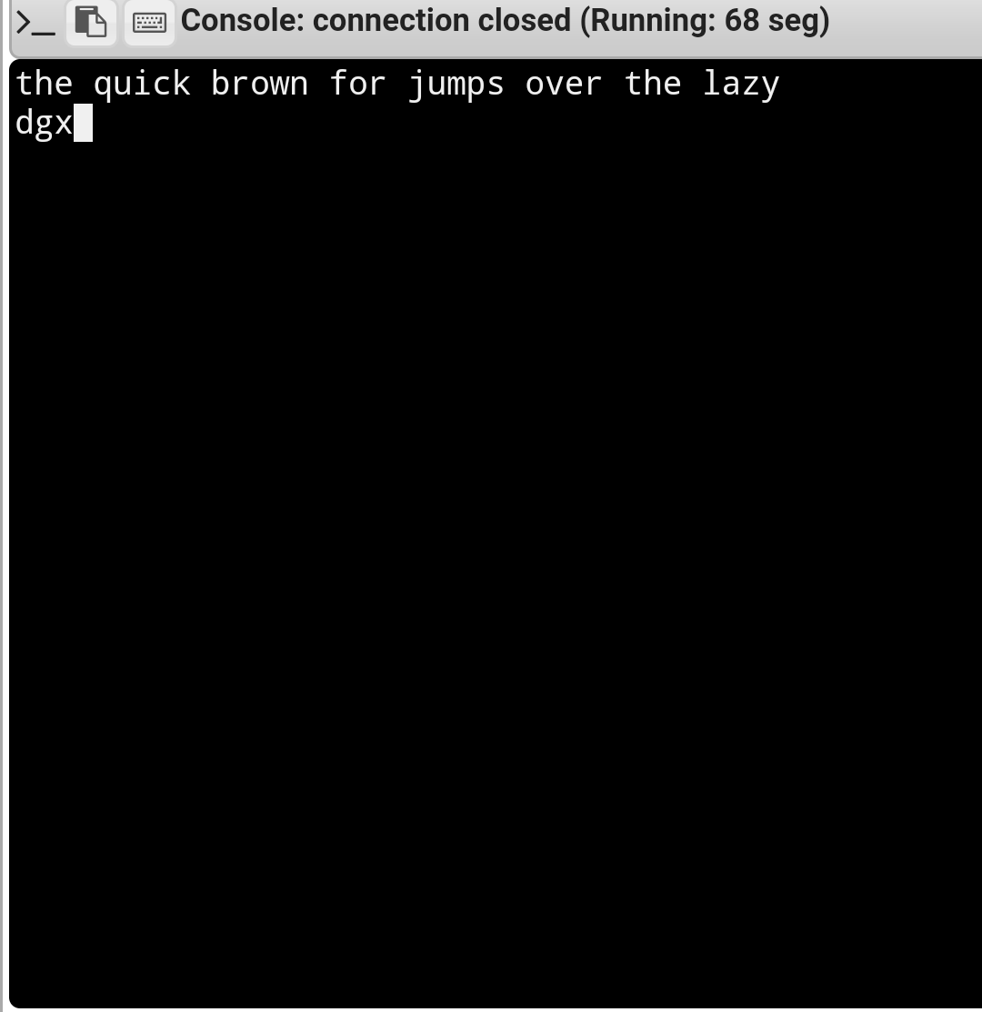
RESULT:
Finding the missing characters is done and the output is verified.

